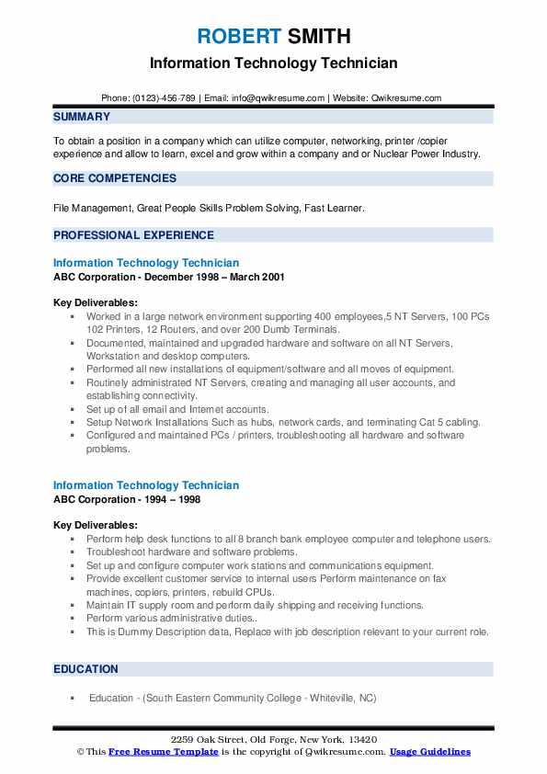
ROBERT SMITH
Information Technology Technician
Phone: (0123)-456-789 | Email: info@qwikresume.com | Website: Qwikresume.com
SUMMARY
To obtain a position in a company which can utilize computer, networking, printer /copier experience and allow to learn, excel and grow within a company and or Nuclear Power Industry. CORE COMPETENCIES
File Management, Great People Skills Problem Solving, Fast Learner.
PROFESSIONAL EXPERIENCE
Information Technology Technician
ABC Corporation - December 1998 - March 2001
Key Deliverables:
• Worked in a large network environment supporting 400 employees, 5 NT Servers, 100 PCs 102 Printers, 12 Routers, and over 200 Dumb Terminals.
⚫ Documented, maintained and upgraded hardware and software on all NT Servers, Workstation and desktop computers.
⚫ Performed all new installations of equipment/software and all moves of equipment.
⚫ Routinely administrated NT Servers, creating and managing all user accounts, and establishing connectivity.
⚫Set up of all email and Intem et accounts.
⚫ Setup Network Installations Such as hubs, network cards, and terminating Cat 5 cabling. ⚫ Configured and maintained PCs / printers, troubleshooting all hardware and software problems.
Information Technology Technician
ABC Corporation - 1994 - 1998
Key Deliverables:
Perform help desk functions to all 8 branch bank employee computer and telephone users. • Troubleshoot hardware and software problems.
• Set up and configure computer work stations and communications equipment.
•
Provide excellent customer service to internal users Perform maintenance on fax machines, copiers, printers, rebuild CPUs...
• Maintain IT supply room and perform daily shipping and receiving functions.
• Perform various administrative duties..
This is Dummy Description data, Replace with job description relevant to your current role.
EDUCATION
Education (South Eastern Community College-Whiteville, NC)
2259 Oak Street, Old Forge, New York, 13420
This Free Resume Template is the copyright of Qwikresume.com. Usage Guidelines

